**National university of computer & emerging sciences**

**Karachi campus**

**Project proposal**



**VOIP Phone System**

**Computer Networks**

**Section: BAI-6A**

**Group members:**

**21k-3062 Hairam Naseem**

**21k-3061 Haris Jamal**

**21k-3006 Mohib Ahmed**

**Introduction:**

In today's interconnected world, communication is the cornerstone of success for any organization. Traditional telephone systems are rapidly being replaced by Voice over Internet Protocol (VoIP) systems due to their cost-effectiveness, scalability, and flexibility. This project proposal aims to implement a VoIP phone system, leveraging computer networks, to streamline communication within an organization.

**Objective:**

The primary objective of this project is to design and implement a VoIP phone system that offers reliable voice communication over an IP network.

**Specific objectives include:**Set up a secure and efficient VoIP infrastructure.   
Implement features such as call routing, voicemail, call forwarding, and conference calling.   
Ensure Quality of Service (QoS) to maintain voice clarity and minimize latency. Integrate the VoIP system with existing network infrastructure seamlessly. Provide scalability for future expansion and growth of the organization.

**Topology:**

The VoIP phone system will be implemented using a client-server architecture over the organization's existing computer network infrastructure.

**The network topology will consist of the following components:**   
VoIP Server: Hosted internally or in the cloud, the VoIP server manages call routing, user authentication, voicemail, and other telephony services.   
IP Phones/Devices: These specialized devices connect to the network and use the Internet Protocol to transmit voice data.   
Switches and Routers: Networking devices that facilitate data transmission between IP phones, the VoIP server, and other networked devices.

**Topology:**

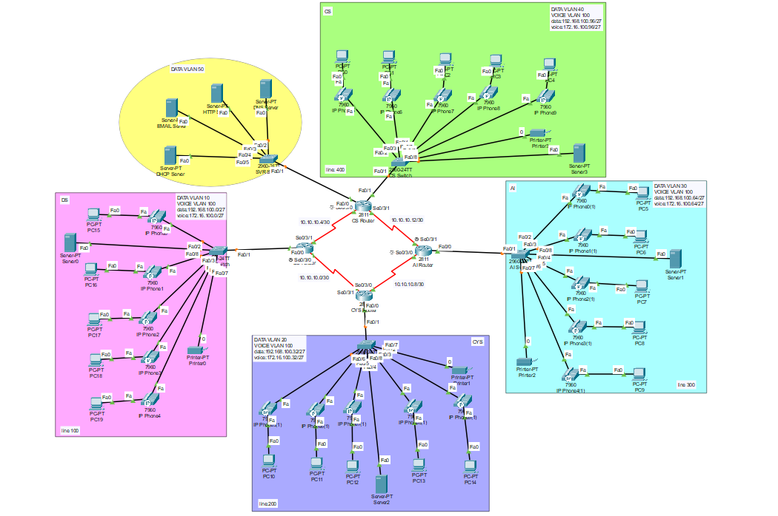

**Conclusion:**

Implementing a VoIP phone system offers numerous benefits, including cost savings, enhanced scalability, and improved communication efficiency. By leveraging computer networks, organizations can transform their communication infrastructure to meet the demands of the digital age. This project proposal outlines a comprehensive approach to designing and implementing a VoIP phone system, ensuring seamless integration with existing network infrastructure, and delivering reliable voice communication services.